

**School of Energy and Electronic Engineering**

Name: Reginald Bayoan

Student ID: 805058

Project Title: Raspberry Pi Application

Course: Computer Engineering

Supervisor: Mr Manish Malik

Academic year: 2018/19



DECLARATION

Declaration of Originality and Approval of Research Ethics

Project Title: Raspberry Pi Application

Student Name: Reginald Bayoan

HEMIS Number: 805058

‘I certify that this is my own work, and it has not previously been submitted for any assessed qualification. I certify that School of Engineering research ethics approval has been obtained and the use of material from other sources has been properly and fully acknowledged in the text’.

Signed: Reginald Bayoan Dated: 9/5/19

ABSTRACT

In the UK, nearly 24.7 million motorists think that parking rules and regulations are confusing,

64% will always appeal a parking ticket whilst one third say the most annoying parking habit is drivers taking up more than one parking space. The research highlighted that half of motorists in the UK are often unaware of their rights with regards to parking and a further 1 in 10 do not know the difference between the rules for parking in a council or private car park.

Very big companies have been working on autonomous vehicles in the past 20 years, and the primary reason for this research is people having difficulties in parallel parking.

The specification of this project is to build a robot car that is able to autonomously park into at least one predefined scenario; like the owner’s garage using a Raspberry Pi and associated sensors.

The robot must also use a camera for image and video processing, as well as use Bluetooth for the owner to connect to the car.

The approach taken on this project is researching on different components, comparing and contrasting its advantages and limitations to help with deciding on the most suitable components for the robot to use.

In the end, the findings were that the robot was able to implement all the points in the specification. However, there are still lots of room for improvement on every aspect of the robot.

Contents

DECLARATION i

ABSTRACT ii

Table of Figures iv

Table of Tables vi

SYMBOLS AND ABBREVIATIONS vi

1. INTRODUCTION 1

1.1 Project Specification 1

1.2 Aims 1

1.3 Objectives 1

1.4 Problem Statement 2

2. LITERATURE REVIEW 2

2.1 Automated Vehicles 2

2.2 Self-Parking Technology 3

2.3 Car Parking Techniques 3

2.4 Self-Parking Robot 4

3. Analysis and design 4

3.1 Hardware 7

3.1.1 Raspberry Pi 3B+ 7

3.1.2 L298N Motor Driver (H-Bridge) 8

3.1.3 Chassis Kit 8

3.1.4 Ultrasonic Sensors 9

3.1.5 USB Camera 9

3.1.6 LEDs + Buzzer System 10

3.1.7 Wireless Keyboard 10

3.2 Software 11

3.2.1 Programming Language 11

3.2.2 OpenCV 11

3.2.3 VNC Viewer 11

3.2.4 Pyzbar 12

3.2.5 Tkinter 12

3.3 Hardware Design Ideas 12

3.4 Software Design Ideas 12

4. TESTING AND IMPLEMENTATION 13

4.3 Raspberry Pi 3B+ 13

4.4 Chassis 15

4.5 Motors 16

4.5.1 Testing the Motors 18

4.6 Ultrasonic Sensors 18

4.6.1 Testing the Ultrasonic Sensors 19

4.7 Camera 21

4.7.1 Face Recognition 21

4.7.2 QR Code Scanning 27

4.8 Self-Parking 29

4.8.1 Parallel Parking 29

4.8.2 Bay Parking 30

4.8.3 Garage Parking/Homing Mode 31

4.8.4 Object Avoidance + Manual Control 32

5. CONCLUSION 33

REFERENCES 34

LIST OF ACHIEVEMENTS 35

Project Achievements 35

Learning Achievements 35

Table of Figures

Figure 1: Gantt Chart 7

Figure 2: Raspberry Pi 3B+ 7

Figure 3: L298N Motor Driver 8

Figure 4: 4WD Chassis Kit 8

Figure 5: Measuring Distances Using Ultrasonic Sensors 9

Figure 6: Camera Module 9

Figure 7: LEDs + Buzzer System 10

Figure 8: Wireless Keyboard 10

Figure 9: Hardware Design Diagram 12

Figure 10: Software Design Diagram 13

Figure 11: A screenshot of Raspbian Operating System with the built-in Python IDE 13

Figure 12: A screenshot of the e-mail with the IS Service Desk about "Eduroam" and the Raspberry Pi 14

Figure 13: Enabling the **Camera**, **SSH**, and **VNC** 14

Figure 14: Raspberry Pi Connection to Other Parts of the Robot 15

Figure 15: Assembling the Chassis 15

Figure 16: Laser Printing Process 16

Figure 17: Time Delay 16

Figure 18: Pulse Width Modulation 17

Figure 19: Integrating the Motors with the Raspberry Pi 18

Figure 20: Voltage Divider Circuit Diagram and Equation 18

Figure 21: Voltage Divider with Ultrasonic Sensor 19

Figure 22: Testing the Ultrasonic Sensors 19

Figure 23: Adding Front Ultrasonic Sensor 20

Figure 24: Four Sides of the Robot with Ultrasonic Sensors 20

Figure 25: Code for Opening the Camera Using OpenCV 21

Figure 26: Image Sample from Initial USB Camera 21

Figure 27: Image Sample from a Better-Quality Camera 22

Figure 28: Converting Coloured to Grayscale 22

Figure 29: Prints the Coordinates of the Region of Interest 23

Figure 30: Showing the Coordinates of the Region of Interest When a Face is Detected 23

Figure 31: Line to Draw a Coloured Rectangle Around the Region on Interest 23

Figure 32: Coloured Rectangle Around the Detected Face 23

Figure 33: Two Sets of Images of Different People 24

Figure 34: Folders of Images Used for Training 24

Figure 35: Assigning Labels to Every Image 25

Figure 36: Implementing Face Recognition 26

Figure 37: Face is Detected but Isn’t Recognised 26

Figure 38: Robot Able to Recognise Both Faces 27

Figure 39: QR Codes 28

Figure 40: Robot Parallel Parking 29

Figure 41: Robot Bay Parking 30

Figure 42: Homing Mode 31

Figure 43: Object Avoidance with Manual Control 32

Table of Tables

SYMBOLS AND ABBREVIATIONS

**Ω** Ohms

*V* Voltage

# INTRODUCTION

## Project Specification

The specification of this project is to build a robot car that is able to autonomously park into at least one predefined scenario; like the owner’s garage using Raspberry Pi and associated sensors.

## Aims

The aims of this project are:

* Design and implement a self-parking robot.
* The robot should use ultrasonic sensors to measure distances and avoid obstacles.
* The user must use Bluetooth to connect to the robot car.
* The robot should use a camera for image processing.
* Before the car begins parking, it checks with the user about its decision on the chosen scenario.

## Objectives

The objectives carried out in order to meet the aims are:

* Conduct research on current autonomous robots/self-driving cars.
* Research hardware solutions for the robot
* Research software solutions for the robot
* Propose a robot design
* Proposed design will go into implementation
* Testing phase in each scenario to make the system more robust and improve design over some iterations and also collect data on reliability of the system (false positives etc).

## Problem Statement

Data collected by the USA Today (USA TODAY, 2017) shows that drivers spend an average of 17 hours a year searching for parking spots. Nearly 42% of the US respondents said they missed an appointment, 34% abandoned a trip because of parking issues and 23% experienced road rage. Furthermore, an estimated $345 per driver in wasted time, fuel and emissions, according to analysis by INRIX, a leading specialist in connected car services and transportation analytics. This shows that parking problems extends worldwide, especially in very high populated cities such as New York, Los Angeles and London.

In the UK, nearly 24.7 million motorists think that parking rules and regulations are confusing, according to a report following research commissioned by the BPA Approved Operators (British Parking Association, 2014). 64% will always appeal a parking ticket whilst one third say the most annoying parking habit is drivers taking up more than one parking space. The research highlighted that half of motorists in the UK are often unaware of their rights with regards to parking and a further 1 in 10 do not know the difference between the rules for parking in a council or private car park.

# LITERATURE REVIEW

## 2.1 Automated Vehicles

Often times when discussing self-driving cars or autonomous vehicles, references to “levels” – Level 4, Level 5 and so on will be present. These levels are a way to describe the amount of automation provided a particular automotive system. According to SAE International, there are six levels of vehicle automation, from Level 0 to Level 5: (Rosevear, J. 2017).

Level 0 – No automation, the human driver has full access to the vehicle. There may be something that intervenes in a very specific situation, like an automated emergency braking system, but these are not considered as “automation”.

Level 1 – this level provides adaptive cruise control, which means that the car has the ability to assist on either steering and accelerating-and-braking control of the car. This can help assist to maintain distance between vehicles but still relies on the human to take control of driving.

Level 2 – this level provides assistance on both steering and accelerating-and-braking control of the car, under limited circumstances. The human will still be expected to intervene regularly and thus the human still needs to have full awareness of its surroundings. An example of this is Tesla’s original Autopilot.

Level 3 – this level still focuses on the assistance on steering and accelerating-and-braking control of the car but this time the car will be self-driving. The human driver does not need to intervene when the system is operating, but the driver will still need some awareness to its surroundings.

Level 4 – this level is considered “High Automation “. This usually means the system does not need human intervention in most circumstances. A typical Level 4 self-driving system would be vehicles that relies on special maps to navigate around. In other words, if the vehicle does not recognise its location or surroundings, the system will signal the need for the human to take over.

Level 5 – this level is “full automation”. This means that the system can drive the vehicle in any circumstances. It can go anywhere there are passable roads, with no human intervention needed at any time.

## 2.2 Self-Parking Technology

Cars can now park themselves with little to no input from a human. It’s become clear that the idea is becoming mainstream, but the technology behind it is not commonly understood. The selling point for autonomous cars is usually ease of lifestyle. For instance, a person would want to go to a store, get out of the car, then tell it to go park itself. Then once the person finishes shopping, the human would press a button, then the car drives back to its driver to pick them up. This is usually what appeals to most people when discussing self-driving cars, not the safety and environmental benefits an autonomous vehicle can provide (Turpen, A. 2016).

Major automotive manufacturers such as Ford, BMW, Mercedes-Benz, Toyota and Volkswagen are now working on automated or semi-automated parking and have introduced them in their vehicles.

According to Aaron Turpen, the basic idea for parallel parking starts with finding a suitable parking space. It will take into consideration different variables such as the space’s size and the amount of room for manoeuvre.

Sensors on the front and rear bumpers of the vehicle can be used to detect most of the variables involved. Sensors used for park-assist usually use electromagnetic or ultrasonic detection to determine the distance to and size of an object near the vehicle. From the data given back by the sensors, the parking system will set the best course of action for parking.

## 2.3 Car Parking Techniques

Parallel parking is where you park your car in line with other cars parallel to the curb. Parallel parking spaces are usually located on the side of the streets and this technique gives problems to some people, as it requires a certain technique to park the car properly.

To parallel park, you first drive your car next to the car you’re parallel parking on. This is the car that will be at the front of your car once you are inside your parking space. Next, you line up your side mirror to their side mirror, then you move back slowly, with the wheel turned towards the curb. Now still moving back slowly, you turn your wheel away from the curb. Keep in mind that you always have to make sure that there is enough space for your car to manoeuvre for when you leave the parking space (Silderhuis, H. n.d).

Next type of parking is bay parking, which means parking the cars side by side, perpendicular to the wall.

Angled parking is similar to bay parking, but just aligned at an angle. Usually, the angle is in the direction of the cars making it easier to approach the parking space. Instead of a full 90-degree turn, angled parking has a slight easier turn, making it easier to park into the parking space.

Double Parking is when someone has parked their car in a way that prevents another car from getting out of their parking space. This is usually caused by larger cars, as it forces them to cover two parking spaces and at the same time blocking another cars path.

## 2.4 Self-Parking Robot

From articles published by John Rosevear, Aaron Turpen and Silderhuis, implementing self-parking capabilities to a robot is a good first step into solving problems related to parking difficulties and confusions about parking rules and regulations. A self-parking robot will most likely be considered Level 2 or Level 3, if the robot will have self-parking capabilities but at the same time must be able to hand over control to the driver. Then using sensors to measure distances to objects and detecting parking spaces can be achieved by the robot.

# Analysis and design

* From the specification, the objective is to build a robot car that is able to autonomously park into at least one predefined scenario: like the owner's garage using Raspberry Pi and associated sensors. It must be able to avoid obstacles when moving towards the garage. The car will start only if it recognises the face of registered driver/ owner.

Ideas for when the robot car is not in homing mode:

1. The robot will be using ultrasonic sensors to measure distances and avoid obstacles.

2. Use Bluetooth to connect to the robot car + camera for image processing.

3. Before the car begins parking, it checks with the user about its decision on the chosen scenario. There will be testing done in each scenario to make the system more robust and improve design over some iterations and also collect data on reliability of the system (false positives etc). Also make the human take over the auto mode if they wish to do so when the car is in auto mode already to prevent damage etc.

These objectives are broken down into different areas of preliminary research.

1. “Must be able to autonomously park into one predefined scenario” – what are the different scenarios when parking a car?

* Angled Parking
* Bay Parking
* Parallel Parking
* Garage Parking

1. “It must be able to avoid obstacles” – autonomous vehicles use proximity sensors to detect distances to objects. Proximity sensors detects objects using electromagnetic fields, light and sound, each suited to specific situations and environments. Which one is the most suitable for robots and distance measurements?

* Infrared Distance Sensor – this sensor is banned from this project since this is the most commonly used sensor. Another way of detecting objects was preferred for adding a challenge to the project.
* Cameras – Using one or more cameras placed around the robot, it can provide information (distance or object size) using computer stereo vision. Computer stereo vision is the extraction of 3D information from digital images taken by a camera and from this, it can give you distance measurements relative to the object. The drawback to this method is that it requires a computer with high processing power and memory.
* Retroreflective Photoelectric Sensors – these sensors use a transmitter, a receiver and a reflector placed in the sensors’ Line of Sight (LOS). The transmitter will transmit light and the receiver receives the reflection from the reflector. If there is no object in between the transmitter and the reflector, then reflection is high. If there is an object, the light will be interrupted, causing the light received to be less than the transmitted one.

The advantages to using these sensors are:

* + Long sensing range
  + Very fast response time (speed of light)
  + It is less costly
  + Transparent objects can be detected

The limitations of retroreflective photoelectric sensors are:

* Its sensing range can be affected by the colour and reflectivity of the object.
* This system requires a reflector in addition to the transmitter/receiver pair. This makes the system more complex to set up.
* Ultrasonic Sensors - this sensor emits ultrasonic waves and is captured by a receiver after it bounces back from an object. By using the total time taken from when it is transmitted to when it is received and the speed of sound in air (approximately 344 m/s), the distance to the object can be calculated (Machine Design. n.d).

The advantages to using ultrasonic sensors are:

* Ultrasonic sensors are easy to implement, and ultrasonic waves are not dangerous to nearby objects or people.
* Ultrasonic sensors are easily integrated with microcontrollers or a computer.

The limitations of ultrasonic sensors are:

* Since ultrasonic sensors operate using sound waves, they are completely non-functional if there is no air for the sound to travel through.
* Soft materials absorb sound waves so objects covered in soft materials can impose difficulty on sensing the object.
* Ultrasonic sensors have a limited range. Ultrasonic sensor modules such as the HC-SR04 module can provide accurate measurements up to 5 meters.

1. “The car will start only if it recognises the face of the driver/owner” – this automatically requires for a camera module to be used by the robot. Since the Raspberry Pi is being used, a readily available library for image and video processing is OpenCV. This library can be used for facial recognition of the robot.
2. “Also make the human take over the auto mode if they wish to do so when the car is in auto mode already to prevent damage etc” – the Raspberry Pi has a built-in Bluetooth feature therefore connecting to the robot will be easily implemented. All that is needed is a wireless keyboard to connect to the robot and set key presses as driving controls, hence giving the option to interrupt auto mode when needed.

Before purchasing the components needed, a Gantt chart was made to set goals for the year

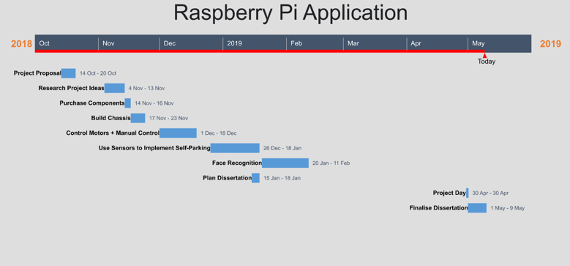

Figure 1: Gantt Chart

## 3.1 Hardware

### 3.1.1 Raspberry Pi 3B+

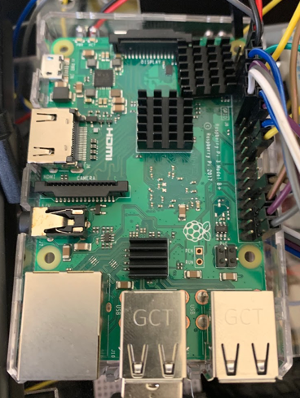

Figure 2: Raspberry Pi 3B+

Raspberry Pi 3B+ provides a built-in Wi-Fi and Bluetooth component, which is useful for connectivity to the robot car as there is no need to add extra components like a Wi-Fi dongle and a Bluetooth module. There’s also 40 General-Purpose Input/output Pins (GPIO Pins) for adding multiple sensors, LEDs and wheel motors, 4x USB 2.0 ports for adding peripherals such as portable power banks and USB video cameras. These features are very useful when building a mobile robot.

### 3.1.2 L298N Motor Driver (H-Bridge)

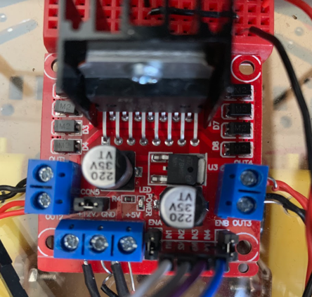

Figure 3: L298N Motor Driver

This IC works on the basic principle of H-Bridge. An H-Bridge is an electronic circuit that switches the polarity of a voltage applied to a load. This means that this motor control circuit allows the voltage to flow in any direction, which also means that interfacing L298N Motor Driver Module with Raspberry Pi will allow the motors to rotate in both directions (forwards and backwards).

### 3.1.3 Chassis Kit

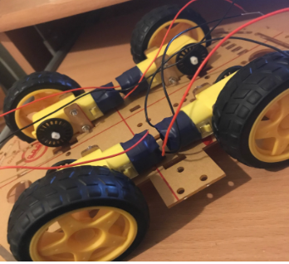

Figure 4: 4WD Chassis Kit

The main components of the robot are the Raspberry PI, a camera module, 4x AA batteries to power the motor driver, a battery pack, and other extra components. The robot should be able to hold all of these components therefore this 4WD chassis kit was chosen as the frame for the robot because it has enough space for all of the components to fit in and can hold a good amount of weight. Another available option was the 2WD chassis kit because it is smaller in size, therefore will take less space and will be easier to steer around. However, it has very limited space for all the components to fit in nicely, and the robot should be manoeuvred similar to how a real car should manoeuvre around which normally have four wheels.

### 3.1.4 Ultrasonic Sensors

For robots to detect obstacles in its surroundings, distance measurement is necessary. The HC-SR04 ultrasonic sensor modules can measure distances up to 4-5 meters. Ultrasonic sensors measure distances by emitting an ultrasound at 40000 Hz which travels through air and if there's an object on its path it will bounce back to the module. Using the travel time and the speed of the ultrasound, the distance to that object can be calculated.

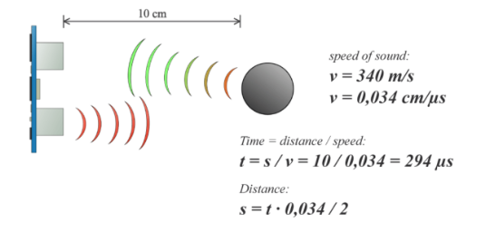

Figure 5: Measuring Distances Using Ultrasonic Sensors

### 3.1.5 USB Camera

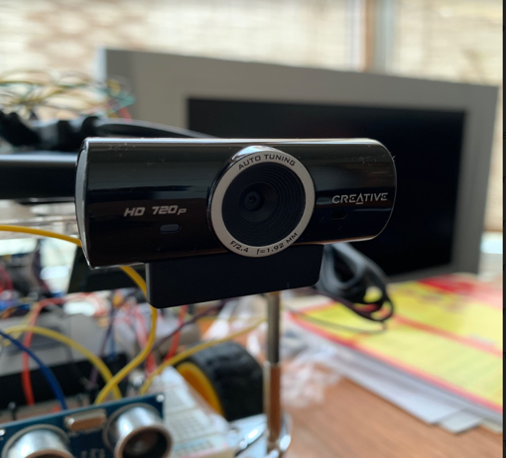

Figure 6: Camera Module

The robot uses the Creative Live Cam Sync HD Webcam. The camera is easy to set up as there is no need to install any drivers from a CD. Just plug it into the Raspberry Pi and is ready to use. Initially, the Raspberry Pi camera was tested, however the Raspberry Pi camera is not readily compatible with OpenCV, which is a library for real-time image and video processing, later used to implement the robot’s face recognition and QR Code scanning functions. On the other hand, a USB camera is readily compatible with OpenCV therefore this camera was chosen.

### 3.1.6 LEDs + Buzzer System

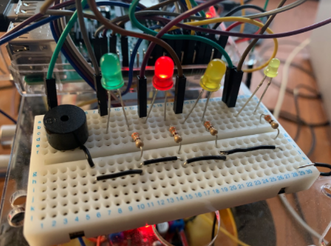

Figure 7: LEDs + Buzzer System

The system will indicate the status of the robot:

* Red LED ON – Robot is locked
* Green LED ON – Robot is unlocked
* Amber LED ON – Robot is in “Auto Mode/Parking Mode”
* Buzzer ON + Small Amber LED ON – Indicates the robot is reversing

### 3.1.7 Wireless Keyboard

A Bluetooth wireless keyboard was used for the “Manual Control” functionality of the car. By pressing keys on the keyboard, the robot performs a function accordingly. The reason for a wireless keyboard is it is faster to transmit signals compared to a remote desktop. If a remote desktop was used to navigate the robot, there is a lag when transmitting data therefore the motors of the robot will move after a slight delay.

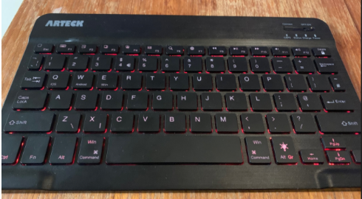

Figure 8: Wireless Keyboard

## 3.2 Software

### 3.2.1 Programming Language

Raspbian is the main and basic software for Raspberry Pi devices. It is an operating system, based on Debian and optimised for Raspberry Pi hardware.

Python language was used because Raspbian comes preloaded with Python, the official programming language of the Raspberry Pi and IDLE 3, a Python Integrated Development Environment.

Other languages are also available to be used on the Raspberry Pi, but Python was chosen for a couple of reasons:

1. It is readily available on the Raspberry Pi.
2. Python is a high-level, powerful language that is ideal for beginners to get started with programming as it has many similarities to other languages. This will be useful when transitioning to other languages in the future.
3. Since Python is a very popular language, there are many resources available whether it is online or programming language books, there is always support when learning Python.

### 3.2.2 OpenCV

OpenCV is a library of programming functions mainly aimed at real-time computer vision. This means that OpenCV can be used for processing images and videos in real time. This is useful for the robot because once the robot picks up information from its environment through the camera, it has to react based on the information received in real time, and OpenCV helps with that. OpenCV was used for face recognition and QR Code scanning, which are explained later at the “Implementation” section.

### 3.2.3 VNC Viewer

Virtual Network Computing (VNC) is a graphical desktop-sharing system that uses the Remote Frame Buffer protocol to remotely control another computer. It transmits the keyboard and mouse events from one computer to another, relaying the graphical-screen updates back in the other directions, over a network.

The VNC viewer used is an application from VNC Connect. This was used to connect a laptop to the Raspberry Pi, allowing the robot to be programmed and controlled remotely.

### 3.2.4 Pyzbar

Pyzbar was used to scan QR codes using the zbar library. This was integrated with OpenCV because OpenCV does not have a built-in library for processing barcodes and QR codes. OpenCV was used for its functionality to take in images for processing, then Pyzbar takes this image and locates and reads the QR code within the image. With this combination, the robot’s “Homing Mode” functionality was implemented.

### 3.2.5 Tkinter

Tkinter is Python’s standard GUI (Graphical User Interface) package and Tkinter allows for binding of Python functions to events. Events can come from various sources, including key presses and mouse operations by the user. Using Tkinter, the robot can be navigated manually by the user through key presses.

## 3.3 Hardware Design Ideas

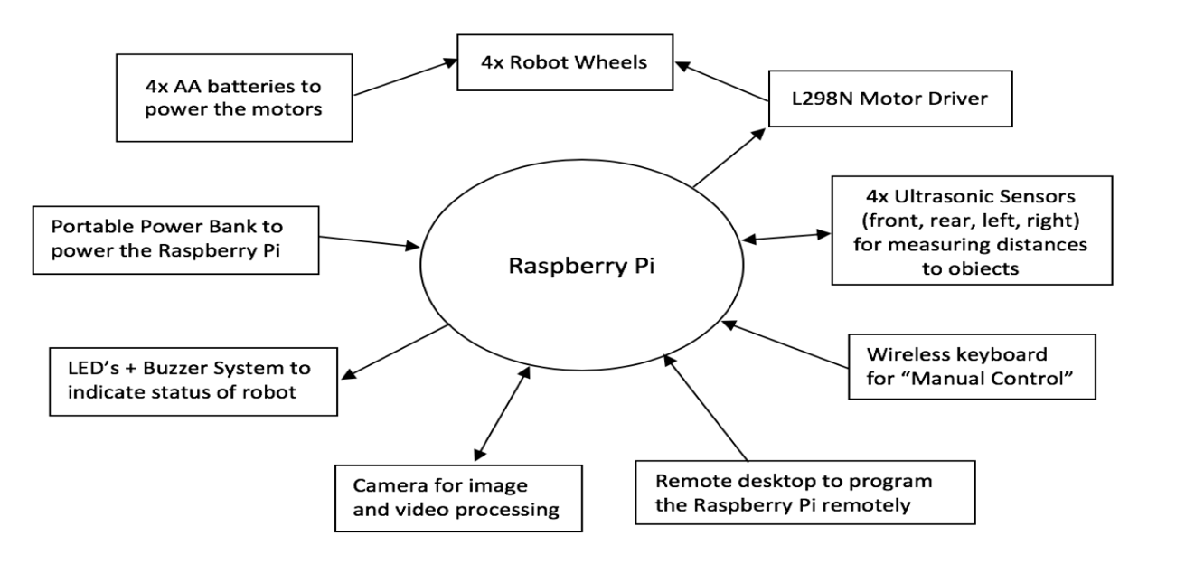

Figure 9: Hardware Design Diagram

## 3.4 Software Design Ideas

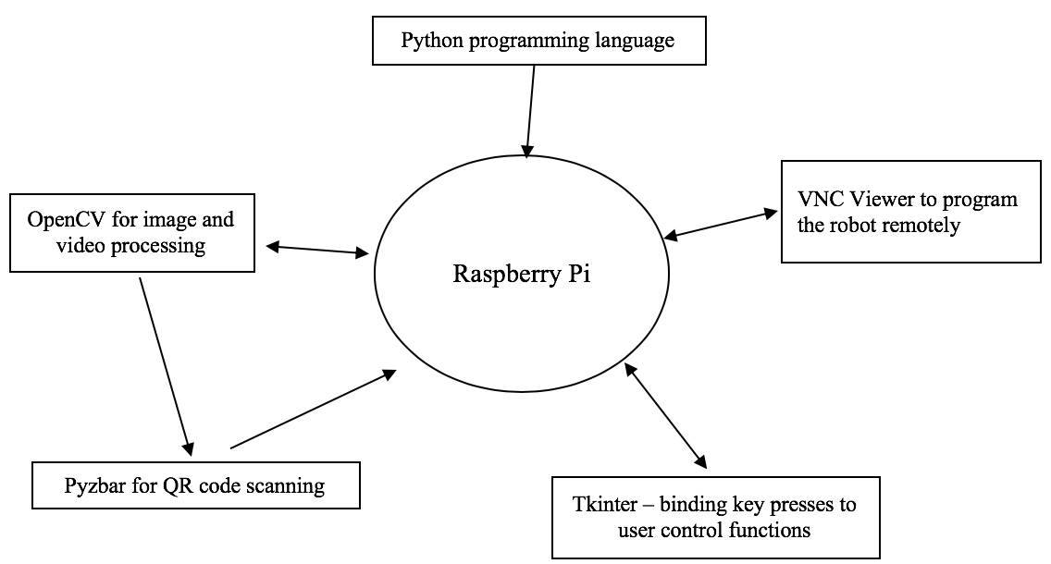

Figure 10: Software Design Diagram

# TESTING AND IMPLEMENTATION

### Raspberry Pi 3B+

The Raspberry Pi that was used came in with a SD Card with NOOBS pre-installed. New Out of Box Software (NOOBS) is an operating system installation manager for the Raspberry Pi. Using this software, the Raspberry Pi was set up to run on Raspbian operating system, which has a built-in Python Integrated Development Environment (IDE). The IDE will be used to write python scripts for the robot system.

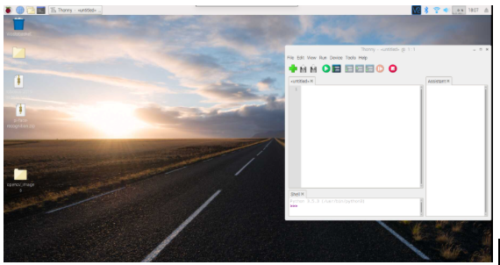

Figure 11: A screenshot of Raspbian Operating System with the built-in Python IDE

The Raspberry Pi was then configured to meet the robot’s specific needs. The Raspberry Pi 3B+ already has a built-in Wi-Fi therefore access to the internet is readily available. A problem encountered however, is that the Raspberry Pi by default, is not allowed to gain access to the university wireless network, “Eduroam”. The university IS Service Desk was asked for help about the situation and an explanation and solution to the problem was provided:

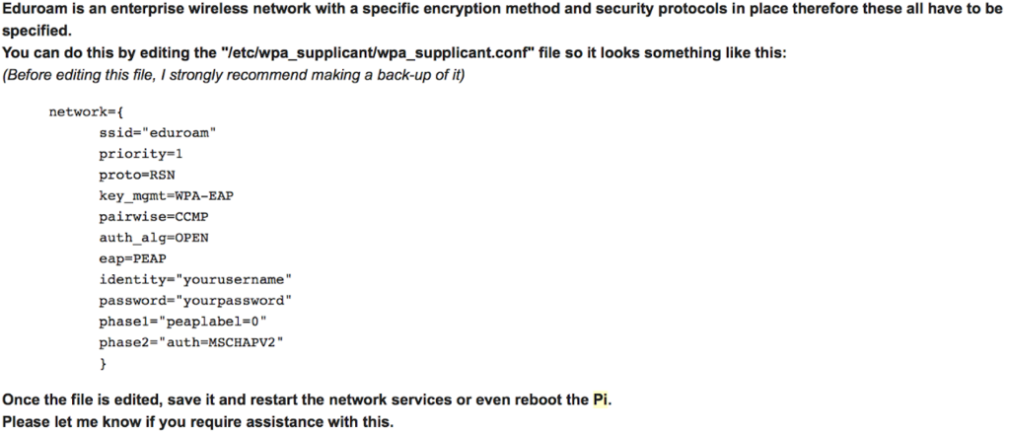

Figure 12: A screenshot of the e-mail with the IS Service Desk about "Eduroam" and the Raspberry Pi

Once the file was modified, the Raspberry Pi was able to gain access to “Eduroam”.

Now that the robot is able to connect to the internet wirelessly, the next step is the robot must be able to use a camera module and the robot must be able to be programmed wirelessly. This was achieved by enabling **Camera**, **SSH** and **VNC** in the **Raspberry Pi Configuration** settings.

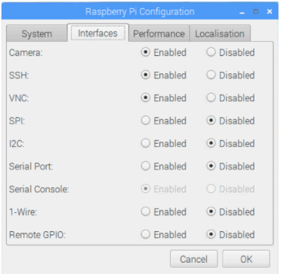

Figure 13: Enabling the **Camera**, **SSH**, and **VNC**

From this, VNC Viewer was installed in order to connect a laptop to the Raspberry Pi, allowing the robot to be programmed wirelessly.

By enabling the **Camera** setting, this allowed the Raspberry Pi camera to be used, but later on changed to a USB camera which is explained on the Camera **Implementation** section.

Furthermore, the Raspberry Pi was also connected to other parts of the system as shown in the diagram below:

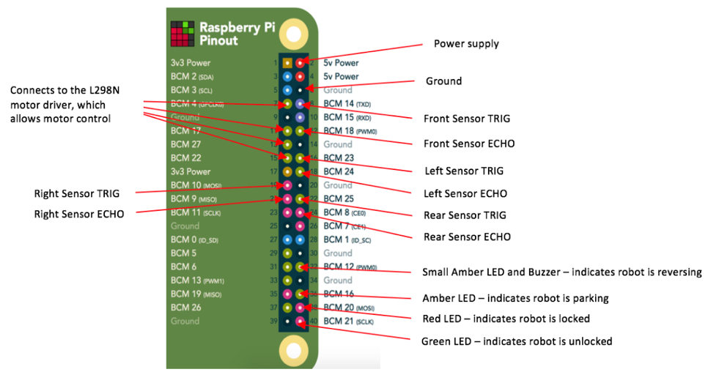

Figure 14: Raspberry Pi Connection to Other Parts of the Robot

### Chassis

A 4WD chassis kit, ordered from Amazon was used for the frame of the robot. This was used as a starting frame due to having no experience in building a robot frame from scratch.

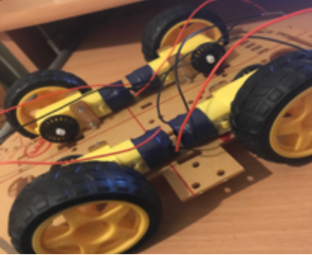

Figure 15: Assembling the Chassis

In the middle stages of the project, as more components are being added to the robot, the space was not enough to fit all of the components together.

The approach taken was to create another level to the robot by scanning the layout of the frame then laser printing a new one.

The university laser printing facility was used to laser print the frame.

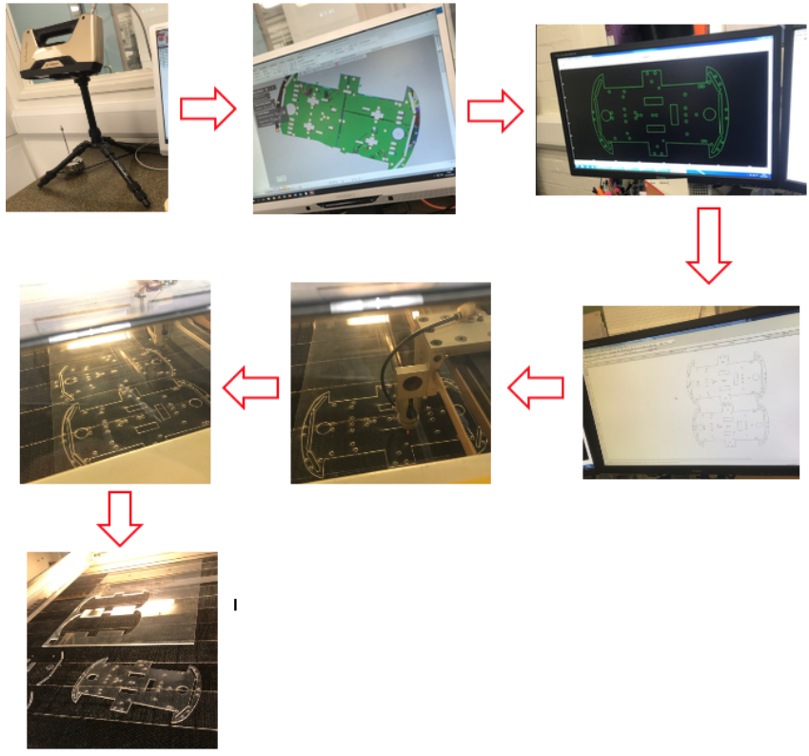

Figure 16: Laser Printing Process

### Motors

The robot has four motors, two left motors and two right motors. The motor driver receives signals from the Raspberry Pi through the input pins IN1, IN2, IN3 and IN4 then outputs signals to the motors through OUT1, OUT2, OUT3 and OUT4. The motor driver also needs a 12V power supply to power it therefore it is also connected to a 4x AA battery pack.

Three different methods have been considered for controlling the DC motors:

1. Time Delays - this method uses time delays to control the DC motors. The idea is to set a time on how long the motors will rotate.

For example, by using this command the motors will rotate for 1s.

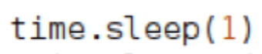

Figure 17: Time Delay

The drawback to this method is that the motors are battery powered and the power of the batteries reduces over time. This means that the power provided by the batteries at full charge will be different to the power provided at 50% charge. As a result, the wheels will rotate fast for 1s at full charge. Then at 50% charge, the wheels will rotate half as fast. This will cause inaccuracy in the distance travelled by the robot because the motors will be rotating at different rates depending on the battery power.

1. PWM - Pulse Width Modulation is a method where you control the motors depending on its duty cycle. Duty cycle is the proportion for which the motor is ON over the total time.

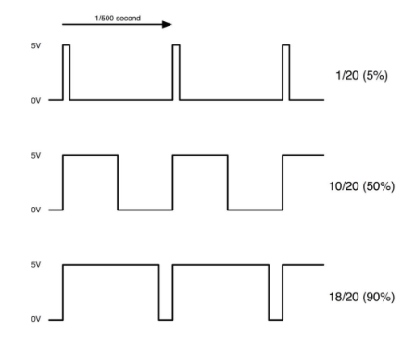

Figure 18: Pulse Width Modulation

The diagram show that the motors will run for 5%, 50% and 90% duration of 1s. This method will only be effective and accurate if the amount of power driving the motors for 1s is constant. This method will run into the same problem as using time delays because the varying battery power will vary the amount of distance travelled by the motors.

1. Wheel Encoders – these sensors convert angular position of the wheel into a digital code. Wheel encoders usually consist of a rotational disk, infrared transmitter and infrared receiver. The rotational disk has a black and white pattern or obstructed and unobstructed pattern on it. When the disk rotates along with the wheel the emitted light is interrupted generating a signal output. Using the number of times, the light has been interrupted (usually referred to as ticks) and the diameter of the wheel, the distance travelled by the robot can be calculated.

After taking all methods into consideration, the method chosen was using time delays because it is very simple to implement on the motors. Integrating wheel encoders with the Raspberry Pi could not be done on time for the project deadline. In future work, wheel encoders would be implemented, since this would allow the robot to be navigated more accurately.

### Testing the Motors

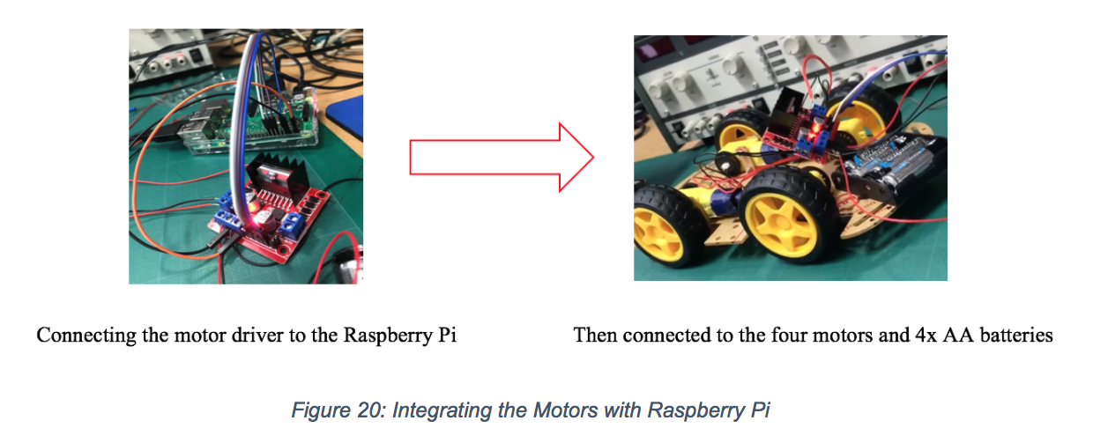

Figure 19: Integrating the Motors with the Raspberry Pi

### Ultrasonic Sensors

The robot has four ultrasonic sensors; front, left, right and rear sensor. These sensors are used for measuring distances between the robot and the objects around it.

The ultrasonic sensor module used is the HC-SR04 module, and it consists of two transducers; transmitter and receiver. How it works is that the Raspberry Pi will send a signal to the TRIG pin of the sensor and from this, the ECHO pin will cause the transmitter to send out ultrasonic sound waves. Once the sound waves hit an object, the sound waves will bounce back and will be received by the receiver. From the total time it takes for the sound waves to travel, the distance to objects can be calculated. The problem however, the received sound waves will be converted into a 5V signal which is going into the Raspberry Pi. The Raspberry Pi GPIO input pins can receive a maximum of 3.3V therefore this 5V signal will need to be lowered down to 3.3V to prevent damage to the GPIO pins. (LTD, M. 2014).

The approach taken was to use a voltage divider:

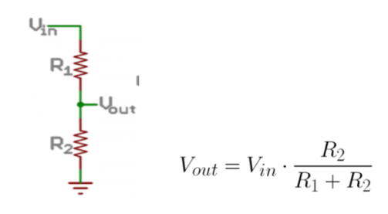

Figure 20: Voltage Divider Circuit Diagram and Equation

The resistors used were 680 ohms (R1) and 1k ohms (R2), to output a voltage of 2.976V. This voltage will be safe enough as an input voltage to the Raspberry Pi GPIO pins.

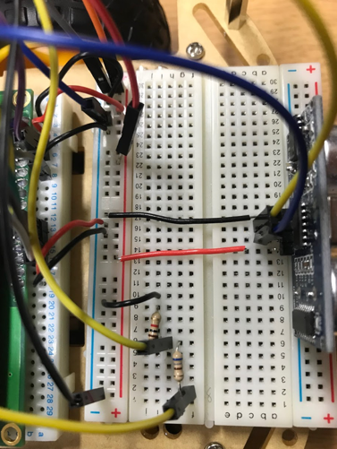

Figure 21: Voltage Divider with Ultrasonic Sensor

### Testing the Ultrasonic Sensors

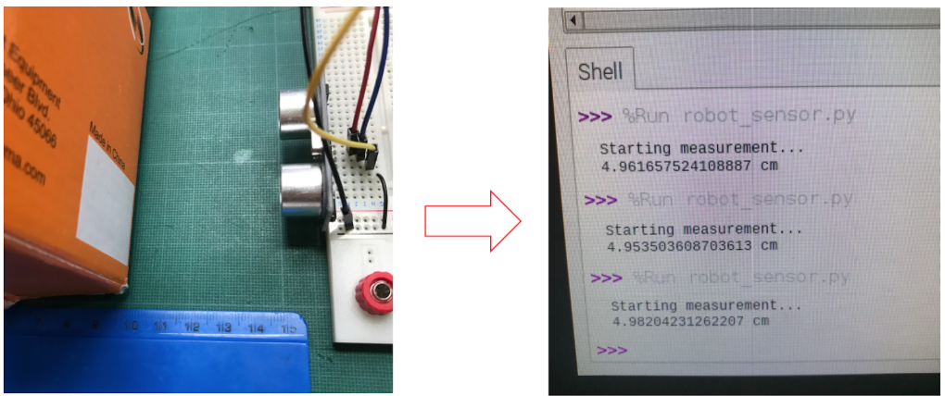

Figure 22: Testing the Ultrasonic Sensors

A box was placed 5cm away from the sensor and a ruler was also placed next to the sensor to compare the measurement of the ultrasonic sensors. The results shown were accurate.

Next, the ultrasonic sensor was attached to the front of the robot shown in the diagram below

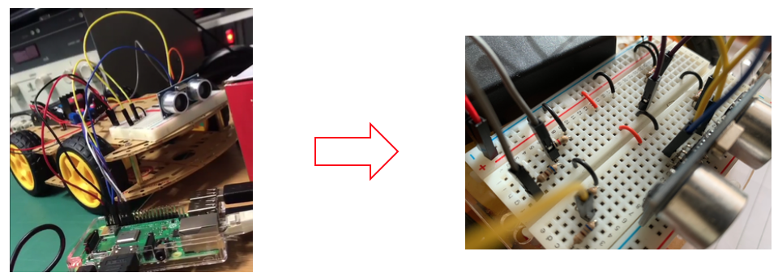

Figure 23: Adding Front Ultrasonic Sensor

Finally, three additional sensors have been attached to the remaining sides of the robot; front, left, right, and rear side.

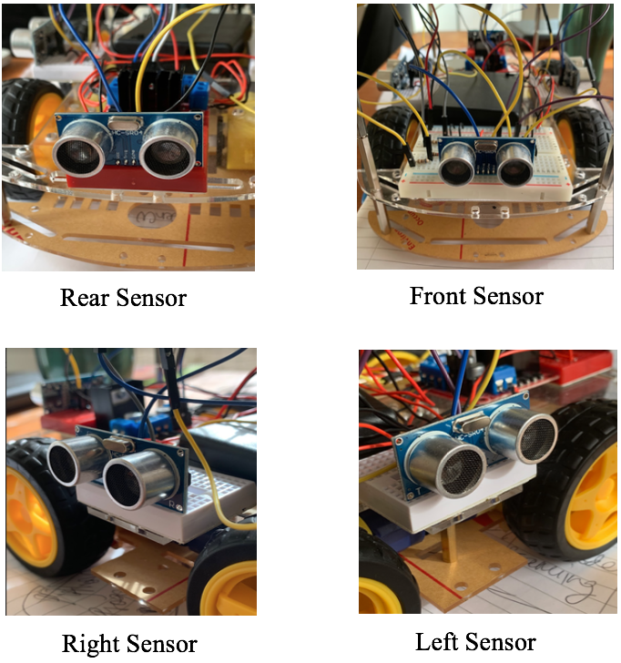

Figure 24: Four Sides of the Robot with Ultrasonic Sensors

### Camera

The robot uses a camera module for face recognition and for scanning QR codes for its “Homing Mode” function.

OpenCV was used for face recognition and Pyzbar was added to assist with reading QR codes.

### Face Recognition

The first step to face recognition is to control the camera. The initial camera used was a camera ordered from Amazon. To run the camera from the Raspberry Pi, OpenCV was imported and the code below was used: CodingEntrepreneurs (2018)

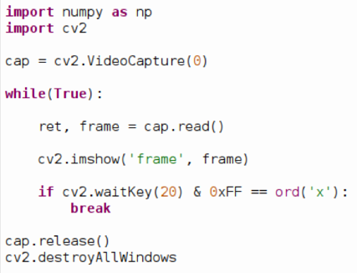

Figure 25: Code for Opening the Camera Using OpenCV

The line cv2.VideoCapture(0) allows to use the default USB camera connected to the Raspberry Pi. Next, to demonstrate the camera is working, a loop is created to capture frame-by-frame then display the resulting frame in a window, labelled ‘frame’. This window will close only if ‘x’ is pressed.

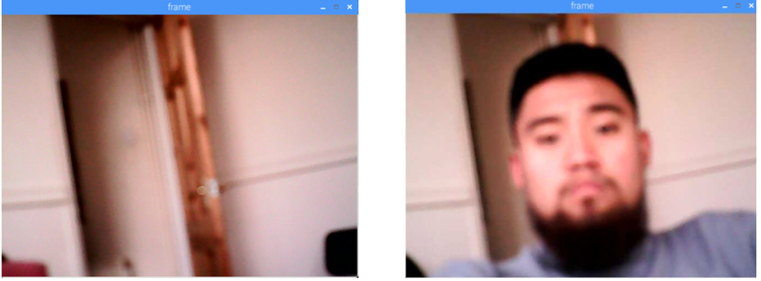

Figure 26: Image Sample from Initial USB Camera

The camera was replaced with a better-quality camera since the camera were showing a very blurry video feed. This could affect the ability of the robot to detect and recognise faces in an image or a video.

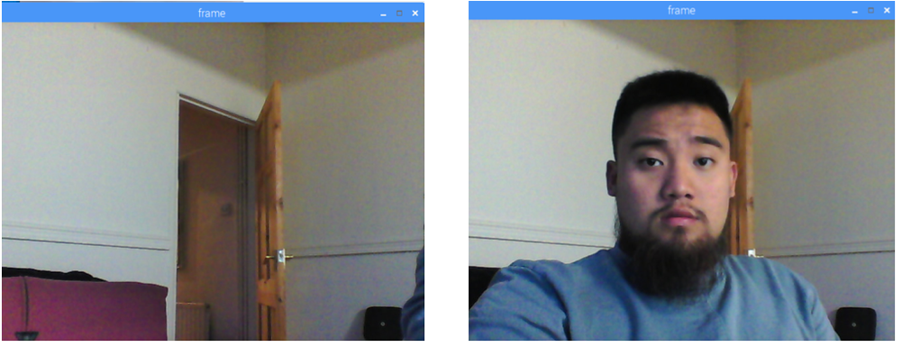

Figure 27: Image Sample from a Better-Quality Camera

The next step is to detect faces inside the frame. To detect faces Haar Cascade classifiers was used, which is a machine learning object detection algorithm used to identify objects in an image or a video. In a nutshell, the Haar Cascade algorithm takes in a lot of positive images (images with faces) and negative images (images without faces) to train the classifier. Faces will have a general pattern; for instance, the region of the eyes is often darker than the region of the nose and cheeks. If a pattern is going from light-dark-light-dark-light, there is a chance that the image can be the face’s right cheek-right eye-nose-left eye-left cheek pattern, hence signalling a face is detected. Haar Cascade already has a library of pre-trained classifiers for eyes, nose, smiles etc.

The classifier used for the robot was the front face classifier.

To test the classifier, an input image is needed. From its documentation, the input image must be converted into a grayscale image.

The line below converts the image from coloured to grayscale:



Figure 28: Converting Coloured to Grayscale

Once a face is detected, it returns the position of the detected face in a form of a bounded rectangle, Rect (x, y, w, h). This rectangle is referred to as the ROI (Region of Interest)

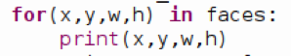

Figure 29: Prints the Coordinates of the Region of Interest

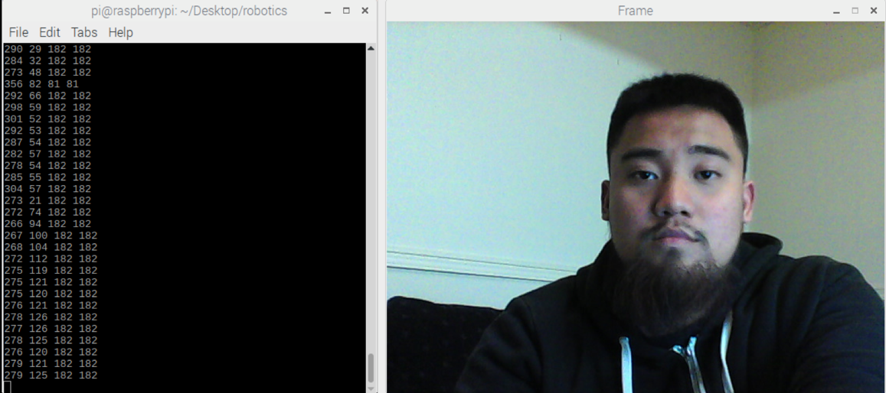

Figure 30: Showing the Coordinates of the Region of Interest When a Face is Detected

A coloured rectangle can be drawn to properly show the Region of Interest by using the line below:



Figure 31: Line to Draw a Coloured Rectangle Around the Region on Interest

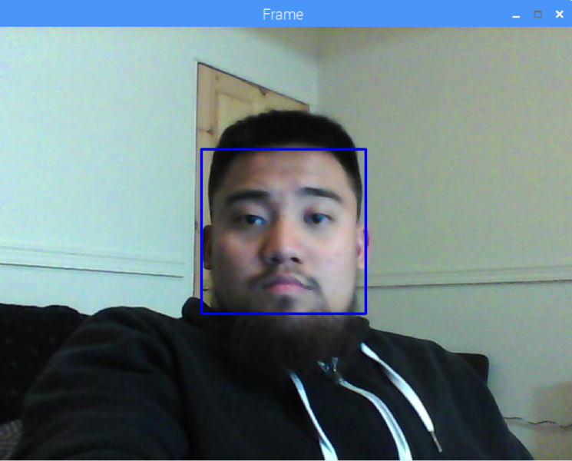

Figure 32: Coloured Rectangle Around the Detected Face

Now that face detection is completed, the question is, “How do you recognise the face?”.

This is when a deep learned model can be implemented to predict things. Examples of these are Keras, TensorFlow or Pytorch.

Instead of using one of these deep learned models such as Keras, a training model was implemented from scratch.

The steps are shown below:

1. Download images with faces in them.

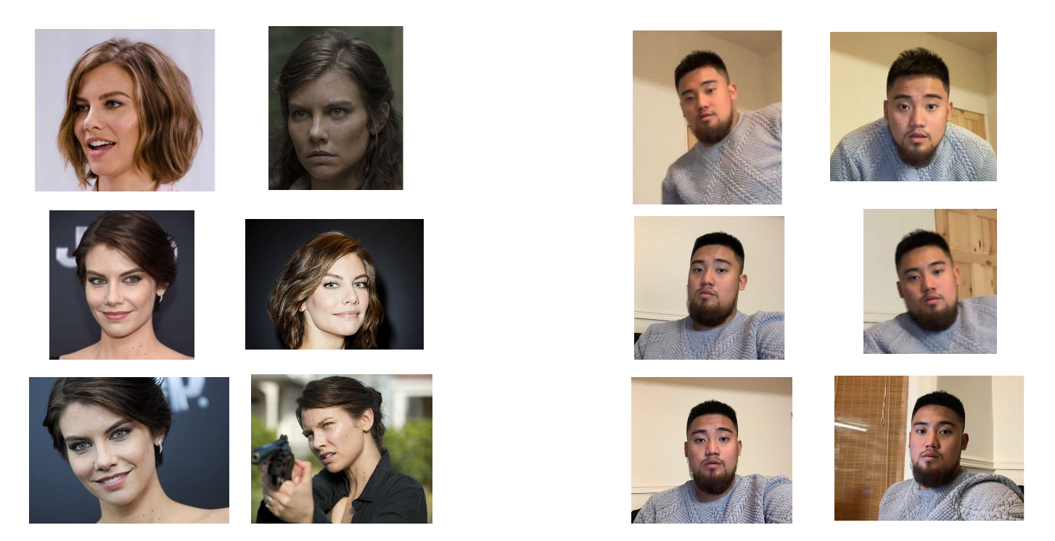

Figure 33: Two Sets of Images of Different People

To see images used for training for face recognition, use link below

<https://drive.google.com/drive/folders/1Ic4D-3fK9lWLC8uu8rKrg66Rnd6GYlPw?usp=sharing>

1. Sort them into folders.



Figure 34: Folders of Images Used for Training

1. Go through all of the images to turn them into trainable data.
2. Using PIL (Python Image Library), these images are converted into grayscale.
3. The images are converted into NumPy arrays. Every pixel of an image is converted into a number, resulting in an array of numbers. It is easier to train on number values instead of pixels of an image.
4. Next, the images are given a label (a name and an ID); For example, ‘maggie’ is assigned ID: 1, ‘regi is assigned ID: 0.

‘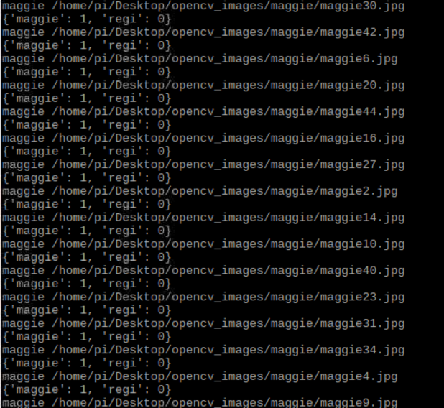

Figure 35: Assigning Labels to Every Image

1. These ID’s are used when a prediction is made on the faces inside the frame.
2. The OpenCV face recogniser is trained. The face recogniser used is the “LBPH Face Recognizer”.
3. Once the training is done, the robot should be able to detect and make predictions to recognise faces.

Different scenarios were tested to verify that face recognition was being implemented correctly.

First, “regi” was able to be recognised by the robot.

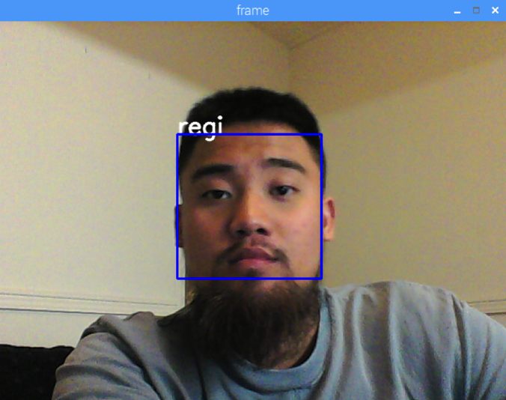

Figure 36: Implementing Face Recognition

Next, a face that the recogniser has not trained for. The expectation is that the face will be detected but will not have a label assigned to it since the recogniser does not have any data on that person.

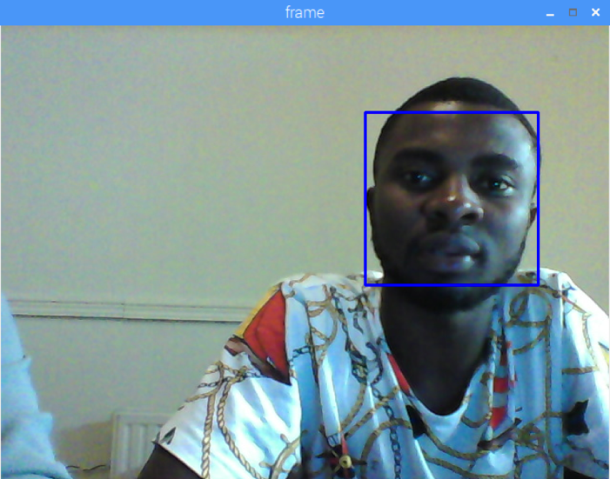

Figure 37: Face is Detected but Isn’t Recognised

Lastly, a test with both “maggie” and “regi” inside the frame.

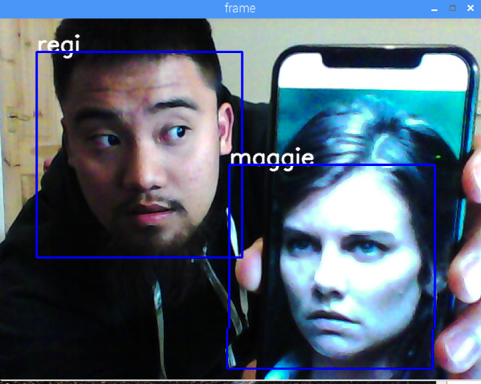

Figure 38: Robot Able to Recognise Both Faces

### QR Code Scanning

QR Codes, also called “quick response codes”, are a pattern of black and white symbols that people can scan to gain more information about a subject, whether it be to learn more about a product, or following a link to a website for further information for an event. These encrypted squares can hold different types of information from simple words, names, directions, event details etc. QR codes are usually found on billboards, posters and even commercials for you to scan quickly with using only your phone (Wainwright, C. 2018).

Another type of technology that uses black and white patterns are barcodes.

The differences between QR code and barcodes are;

1. Barcodes are rectangular in shape; therefore, scanners are mostly shaped horizontally. QR codes are square shaped, therefore can be scanned either vertically or horizontally.
2. QR codes can hold hundreds of times more encrypted data than barcodes. This is due to the square shape of a QR code. It can have more different combinations of black and white patterns hence can hold more data compared to barcodes.
3. They hold different types of data. Barcodes are usually used for key important data such as the price of a product or a name of a manufacturer. On the other hand, QR codes are more commonly used for advertising purposes such as links to a concert or events.

Since IR technology is banned from the project, a different way to implement “Homing Mode” was needed. The idea of using QR Code scanning to follow directions towards a “garage” or base came from observing how cars navigate around a parking lot. Vehicles will usually follow an “EXIT” sign until they reach the exit of the parking lot. Since QR codes are readable and can be unique from each other, this method was suitable to allow the car to navigate to its “home”.

The idea is to take in an image using OpenCV, then the image is then processed by Pyzbar using its QR code scanning functions. Depending on the data extracted from the code, the robot will move accordingly.

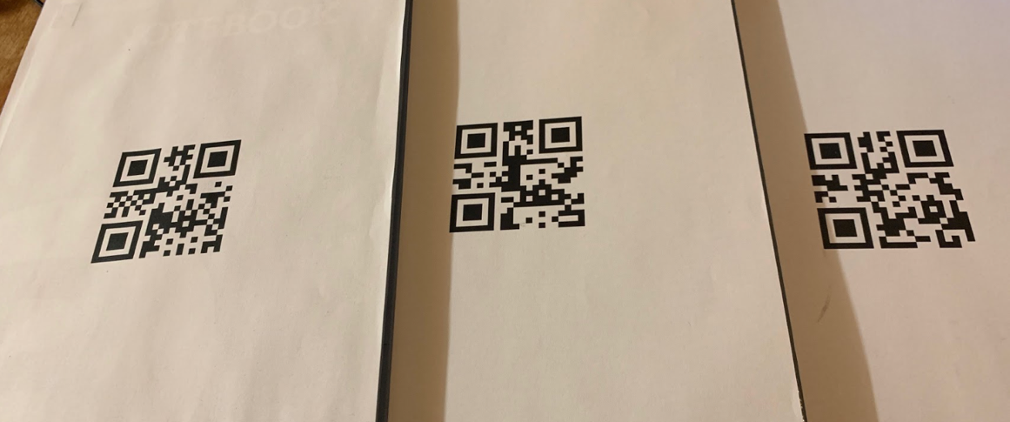

Figure 39: QR Codes

The QR codes above reads “LEFT”, “RIGHT” and “STOP” respectively.

The robot turns to the left if the camera reads a “LEFT”, turns to the right if it reads “RIGHT” and stops if it reads “STOP”.

The testing for this can be seen on the “Self-Parking” section.

### Self-Parking

### Parallel Parking

Algorithm Idea: Move forward

Read side sensor

To perform parallel parking, the robot must have at least 20 inches of space. Since the robot’s motors work using time delays, the robot travels approximately 20 inches by moving forward with 0.5s time delay four times. If the robot senses less space than 20 inches, it will stop parking.

Object detected nearby?

Then Stop Robot

Else move forward

Read side sensor

Object detected nearby?

Then Stop Robot

Else move forward

Read side sensor

Object detected nearby?

Then Stop Robot

Else move forward

Perform Parallel Parking

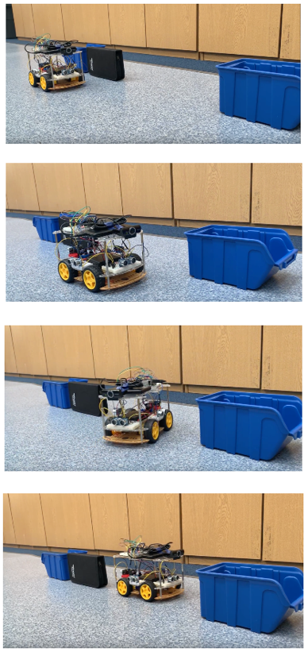

Figure 40: Robot Parallel Parking

### Bay Parking

Algorithm Idea: Move forward

To perform bay parking, the robot must have at least 10 inches of space. The robot travels approximately 10 inches by moving forward with 0.5s time delay three times. If the robot senses less space than 10 inches, it will stop parking.

Read side sensor

Object detected nearby?

Then Stop Robot

Else move forward

Read side sensor

Object detected nearby?

Then Stop Robot

Else move forward

Perform Bay Parking

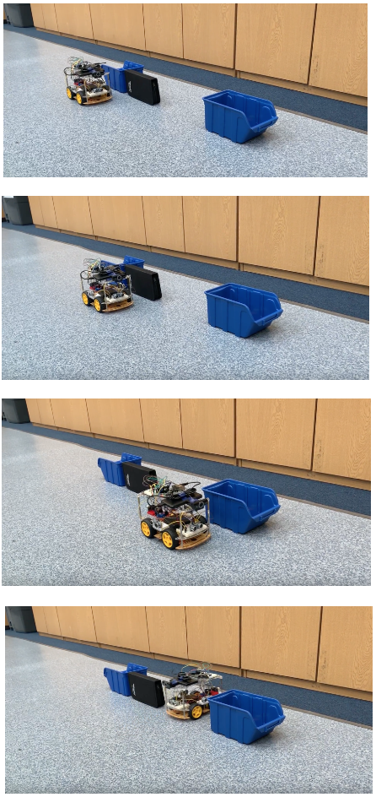

Figure 41: Robot Bay Parking

### Garage Parking/Homing Mode

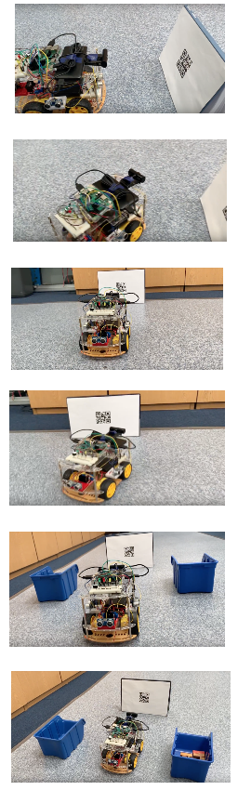

Robot moves towards the garage

Robot reads “STOP”, then robot stops

Robot reads “RIGHT”

Robot turns to the right, then keeps moving forward

Robot turns to the left, then keeps moving forward

Robot reads “LEFT”

Figure 42: Homing Mode

### Object Avoidance + Manual Control

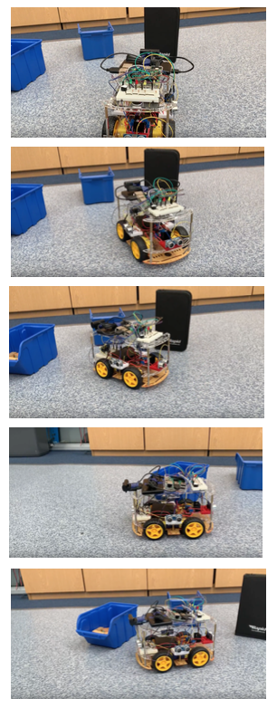

Objects detects another object from its front sensor

Robot avoids object

Robot senses object from its front sensor

Robot avoids object

Went out of bounds so manual control was used to reverse the robot

Figure 43: Object Avoidance with Manual Control

To see videos of testing phase on parking scenarios, use link below

[**https://drive.google.com/drive/folders/1yx0lEFzHCNQFyCrPuwsARlplStaA90NL?usp=sharing**](https://drive.google.com/drive/folders/1yx0lEFzHCNQFyCrPuwsARlplStaA90NL?usp=sharing)

# CONCLUSION

This project has met all of the specifications set out by the supervisor at the beginning:

* The system implements a self-parking robot
* The system uses ultrasonic sensors to measure distances and avoid obstacles
* The system uses Bluetooth to connect to the robot
* The robot uses a camera for image and video processing.
* Before the car begins parking, it allows the user to press a key to decide on which type of parking would be done.
* Testing phase in each parking scenario were done to make the system more robust.

In future work, the use of wheel encoders to control the motors would increase the accuracy of the robot’s navigation. Also, using a deep learning library like Keras or TensorFlow would give the robot more AI capabilities.

Most of the system requirements has been completed within the specified time due to the planning at the preliminary stage of the project. A Gantt chart was used to keep on schedule throughout the academic year.

Lastly, the total costing of the whole project is listed below:

1. Raspberry Pi 3B+ with SD Card (16 GB) - £50
2. L298N motor driver - £12
3. Ultrasonic sensors with jumper wires - £13
4. Creative Live Cam Sync HD Webcam - £14.99
5. Chassis kit - £12.99
6. Power bank - £25
7. Rechargeable batteries with charger - £26
8. Wireless keyboard £ 10

Total Amount - £163.98

REFERENCES

Silderhuis, H. (n.d.). *Car parking techniques*. [online] Parking-net.com. Available at: http://www.parking-net.com/about-parking/car-parking-techniques [Accessed 14 Apr. 2019].

Wainwright, C. (2018). *How to Make a QR Code in 7 Easy Steps*. [online] Blog.hubspot.com. Available at: https://blog.hubspot.com/blog/tabid/6307/bid/29449/how-to-create-a-qr-code-in-4-quick-steps.aspx [Accessed 16 Apr. 2019].

Machine Design. (n.d.). *Proximity Sensors Compared: Inductive, Capacitive, Photoelectric, and Ultrasonic*. [online] Available at: https://www.machinedesign.com/sensors/proximity-sensors-compared-inductive-capacitive-photoelectric-and-ultrasonic [Accessed 2 May 2019].

Rosevear, J. (2017). *The "Levels" of Self-Driving Explained*. [online] The Motley Fool. Available at: https://www.fool.com/investing/2017/04/11/the-levels-of-self-driving-explained.aspx [Accessed 7 May 2019].

Turpen, A. (2016). *How self-parking car technology works: the first step to autonomous vehicles*. [online] Newatlas.com. Available at: https://newatlas.com/how-self-parking-works/46684/ [Accessed 7 May 2019].

LTD, M. (2014). *HC-SR04 Ultrasonic Range Sensor on the Raspberry Pi*. [online] MODMYPI LTD. Available at: https://www.modmypi.com/blog/hc-sr04-ultrasonic-range-sensor-on-the-raspberry-pi [Accessed 9 May 2019].

CodingEntrepreneurs (2018). *OpenCV Python TUTORIAL #4 for Face Recognition and Identification*. [video] Available at: https://www.youtube.com/watch?v=PmZ29Vta7Vc&t=649s [Accessed 9 May 2019].

Tabora, V. (2019). *Face Detection Using OpenCV With Haar Cascade Classifiers*. [online] Becoming Human: Artificial Intelligence Magazine. Available at: https://becominghuman.ai/face-detection-using-opencv-with-haar-cascade-classifiers-941dbb25177 [Accessed 9 May 2019].

Office Timeline Online. (n.d.). *Build native PowerPoint timelines online - Office Timeline Online*. [online] Available at: https://online.officetimeline.com/app/#/new-from-template [Accessed 9 May 2019].

LIST OF ACHIEVEMENTS

## Project Achievements

1. The improvement of the chassis from one level to two levels allowed all the components to fit nicely around the robot. The weight distribution was better since all the components are not being crammed in one place.
2. Ultrasonic sensors were improved from one sensor at the front of the robot to having four sensors; one at the front, left, right and rear side of the robot. This helped increase the amount of parking scenarios the robot can do. In addition, the robot can also perform obstacle avoidance.
3. Image and Video Processing was implemented using OpenCV. Improving face detection to face recognition has helped increase the level of understanding on computer vision.
4. A Buzzer with LED system was put together to indicate the status of the robot.
5. Using QR codes to autonomously navigate the robot towards its home base.
6. Manual control was made possible by using Tkinter and a Bluetooth wireless keyboard.

## Learning Achievements

1. I learned to program in Python.
2. I learned about good practices in coding such as creating virtual environments.
3. I learned about software compatibility. For example, Python 2.7 and Python 3 packages are not the same.
4. I learned navigating around a different operating system (Raspbian).
5. I learned about connecting to another computer from a remote desktop.
6. I learned to implement my own simple face recogniser
7. I learned how barcode and QR code scanning technology works.
8. I gained awareness about the different deep learning libraries available.
9. I learned to manipulate hardware components such as motors and sensors.
10. I learned to properly scan through a component’s information sheet/documentation before using it. For example, the Raspberry Pi’s GPIO input pins can have a maximum input voltage of 3.3V or else will damage the pins.